TDI 80/20 Toluene Diisocyanate CAS 584-84-9 with high quality
Description
Toluene diisocyanate tdi 80/20 is isocyanate ester product, can replaced all or part of the t80, can improved the compression load of the product , toluene diisocyanate tdi 80/20 is widely used in the production of polyester-based soft foam, high-bearing sponges, semi-rigid ester foam, high resilience,slow rebound , paint and other industries.
Specification
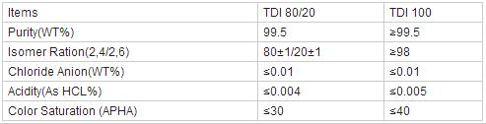​
Storage
Store the product in a ventilated and cool place,prevent from direct sunshine,heat and combustible substances.If the package is damaged and there is any spill,use large quantities of water to flushit.Do store the product on wood pallets or wood floors.
Our company
Xiamen Ditai Chemicals Co., Ltd is an ISO9001:2008 certificated organization. We alway pay attention to the quality control. For us, quality means satisfied clients. Only by constantly improving our internal and external procedures are we able to remain a reliable supplier of chemicals for our clients worldwide. Every step of the distribution chain is constantly checked and rechecked to guarantee the quality. Through continuous improvement in quality and service, we will provide our customers with products of optimum quality consistent with their requirements.
Besides the quality, we think the competitive price of goods is also important. Our comprehensive distribution network, buying power and efficient inventory management system allow us to offer our products at the best possible prices. Our principle is: Quality Chemicals With Competitive Prices - We Supply!
Up to now many of our chemicals have been done REACH final registration. It is convenient for the clients to use our chemicals in Europe market.
Your satisfaction is our most interested thing. Also your any suggestion will be highly welcome by us. Now enjoy your visiting and hope to hearing from you!
Best Regards
Lisa Pan

