厦门迪太进出口有限公司
XIAMEN DITAI IMP.& EXP. CO.,LTD
地址：中国厦门禾祥西路鸿升大厦8A
8FL, Hongsheng Building, West Hexiang Road, Xiamen, Fujian, China
TEL:0592-26808108 FAX:0592-2680880 E-mail: irene.zhang@xmditai.com

Citric Acid For Cleaning CAS 77-92-9

1.The Details of Citric Acid For Cleaning CAS 77-92-9

Product name
Citric acid anhydrous
Other name
2-Hydroxy-1,2,3-propanetricarboxylic acid; Citric acid, anhydrous, CAA; Citric acid anhydrous
CAS NO.
77-92-9
EINECS NO.
201-069-1
Molecular formula
C6H8O7
Packing
25kg/bag
Standard
BP/USP

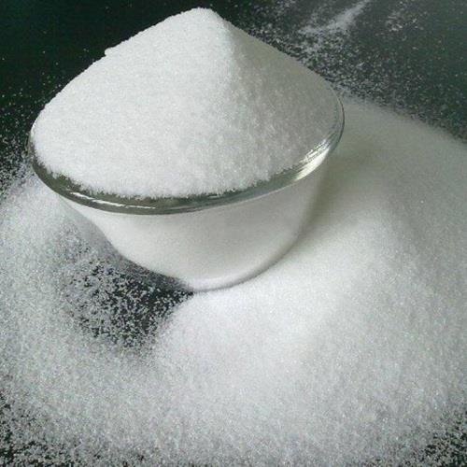

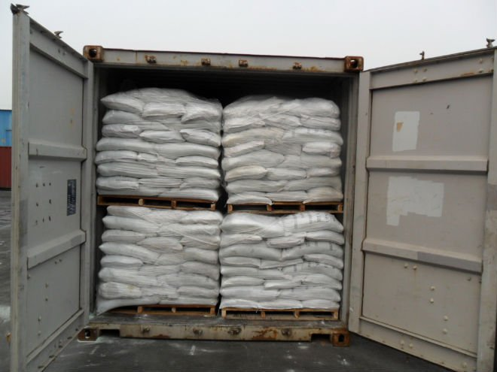

2.The Description of Citric Acid For Cleaning CAS 77-92-9
Items | UNIT | Quality Standards
Identification | ----- | Pass Test
Appearance of Solution | ----- | Pass Test
Assay | % | 99.5-100.5
Sulphate | PPM | ≤150
Oxalate | PPM | ≤100
Chloride | PPM | ≤50
Heavy Metal( as Pb) | PPM | ≤5
Calcium | PPM | ≤75
Iron | PPM | ≤5
Sulphated Ash | % | ≤0.05
Moisture | % | ≤0.5
Readily Carbonisable Substances | ----- | Not Darker than Standard
Lead | PPM | ≤0.5
As | PPM | ≤1
Mercury | PPM | ≤1
Aluminum | PPM | ≤0.2
Barium | ----- | Pass
Bacteria Endotoxin | IU/mg | <0.5
Volatile Organic Impurities | ---- | Pass
Tridodecylamine | PPM | ≤0.1
Ultraviolet Absorbance | ---- | Pass

​

